**DAILY ONLINE ACTIVITIES SUMMARY**

|  |  |  |  |  |  |  |  |  |
| --- | --- | --- | --- | --- | --- | --- | --- | --- |
| **Date:** | **18-06-2020** | | | | | **Name:** | **Sneha K Bakale** | |
| **Sem & Sec** | **6th B** | | | | | **USN:** | **4al17cs095** | |
| **Online Test Summary** | | | | | | | | |
| **Subject** | | **-** | | | | | | |
| **Max. Marks** | | **-** | | **Score** | | | **-** | |
| **Certification Course Summary** | | | | | | | | |
| **Course** | **Programming in C** Workshop on Applications of Python Programming in Data Analytics and Machine Learning | | | | | | | |
| **Certificate Provider** | | | **Mr.Vikek sharma**  **Dr.Badhusha** | | **Duration** | | | **4.0 hours** |
| **Coding Challenges** | | | | | | | | |
| **Problem Statement:**  **Python Programming in Data Analytics and Machine Learning exercise.** | | | | | | | | |
| **Status: Completed** | | | | | | | | |
| **Uploaded the report in Github** | | | | | **Yes** | | | |
| **If yes Repository name** | | | | | **Report-**[**https://github.com/Sneha35/OnlineCourse-And-Coding.git**](https://github.com/Sneha35/OnlineCourse-And-Coding.git)  **Python Programming-**  <https://github.com/Sneha35/Applications-of-python-programming-in-DA-and-ML.git> | | | |
| **Uploaded the report in slack** | | | | | **Yes** | | | |

Online Test Details: (Attach the snapshot and briefly write the report for the same)

Certification Course Details: (Attach the snapshot and briefly write the report for the same) 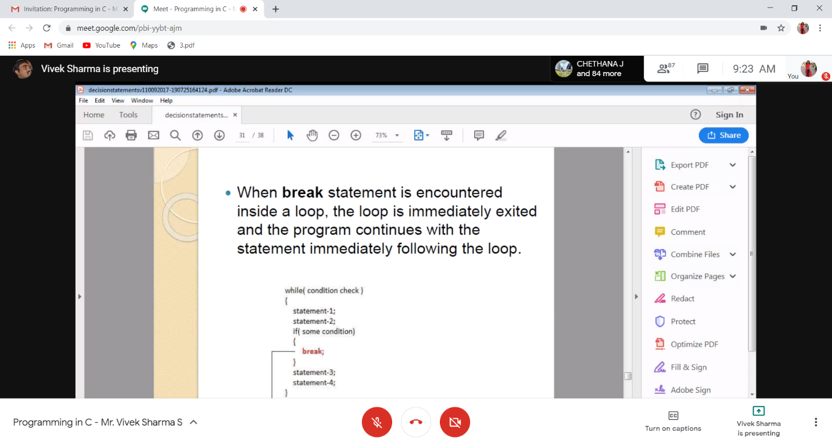

Coding Challenges Details: (Attach the snapshot and briefly write the report for the same)

**Write a C Program to generate first N Magic Numbers.**

#include <stdio.h>

#include <stdlib.h>

int main()

{

int n,b[100],i;

printf("Enter The N: ");

scanf("%d",&n);

for(i=0;i<n;i++)

{

int j=0,a=i+1;

while(a>0)

{

b[j++] = a%2;

a=a/2;

}

int l=j,k,s=0;

for(k=0;k<l;k++)

{

s=s+b[k]*pow(5,(k+1));

}

printf("%d\t",s);

}

return 0;

}

**Output:**

